Introduction

**IMPORTANT**

**In this document I will be recording information which will only be relevant to someone who’s already familiarized with the trading environment and the core concepts of trading like Tendency, Candles, Brokers, Sessions, Spread, Pips etc.**

During these classes I mostly learned to use what is know as Price Action, along with both fundamental and technical analysis of the market. First and foremost, we need some apps installed on our phones and to create account in the corresponding websites and services linked to those accounts. The different services have different uses. The **TradingView** service is used to analyze the market, **Meta Trader 4** will be the service we will use to enter the market and make money and **MyFxBook** will be used as a tool for the “fundamental” part of the analysis.

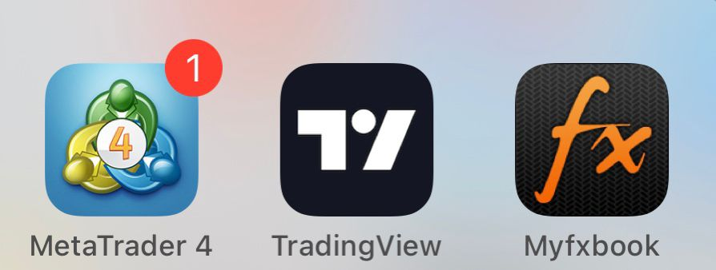

The corresponding websites to these apps are [www.tradingview.com](http://www.tradingview.com) for **TradingView** and the [www.myfxbook.com](http://www.myfxbook.com) for **MyFxBook**. Meta Trader 4 will be used only on our phone for convenience since we can track the price with **TradingView.**

Trading Mind Set

Assuming that you already know the main concepts and have already lost money in the market you should have noticed that focusing on the money can be really tricky when entering the market and it can render you very emotional and irrational.

So, what would be the solution to this problem?

I have found that the main problem when it comes to this issue is that the person is trading with money that is important to them, and they are focused on getting more money. It sounds stupid at this point if I tell you not to focus on the money when that is the main target but believe me, if you trust in your process and focus on your pips, the money WILL follow those pips.

It is important then, that you **NEVER** enter the market with money that is essential to your daily use, or money that is already saved for something like a student loan or a house. Only use money that you don’t need and **ALLWAYS** have some amount of money as a backup. The reason for this is not only making sure that you will not **loose all your money** and stay in zero, but mainly because without this you will be focused on that money because that **money has some value** for you other than **just an asset**, other than just pips.

Once this is all set, what I like to do is to treat it like a game, those pips are just part of the game and forget about the money since that will only make you either afraid to continue trusting your transaction and close it early **loosing an opportunity** to **make your initial pips goal**, or getting too confident and keeping your transaction open after **your goal was reached** and then, then you **lose money**.